**Transferring Bb Media Files and Links to Moodle**

These instructions show 2 ways to move media from Blackboard to Moodle: Media files (mp3, mp4, etc.) or embedded web-videos (YouTube, etc.).

**Media files (mp3, mp4, etc.)**

If you uploaded your own media files into Blackboard, you can copy those same media content **files** from a Blackboard course site (i.e., MP3, MP4, etc.) to a Moodle course site as shown below:

1. Open your Blackboard course.
2. From the Course Management tools in your Blackboard course, click on "Files".
3. Click on the numerical file title to open your course files.

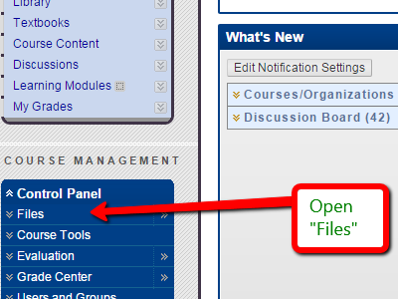 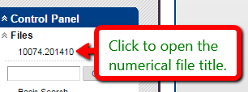

1. Select the specific media files you want to copy over into your Moodle course, then "Download".

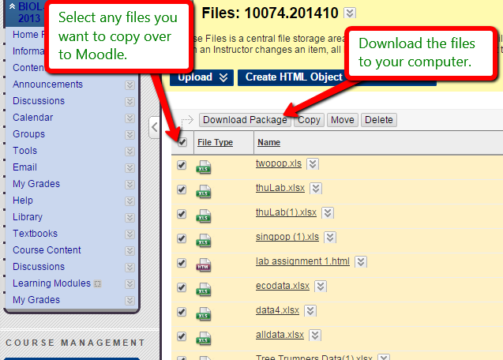

1. The zipped file folder will appear in your computer's "Downloads" folder.
2. Right-click on the zipped file and select "Extract".

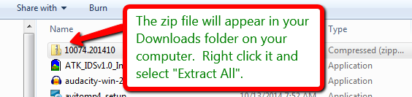

1. In the extraction pop-up, select the option to "show extracted files when complete". You will return to this file collection and copy those same files after you open your Moodle course.

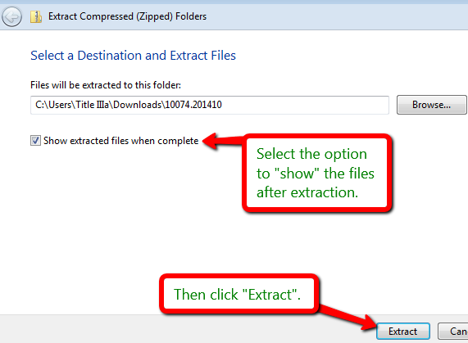 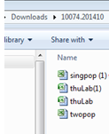

1. Open your Moodle course, and in the top right corner click to "Turn editing on."

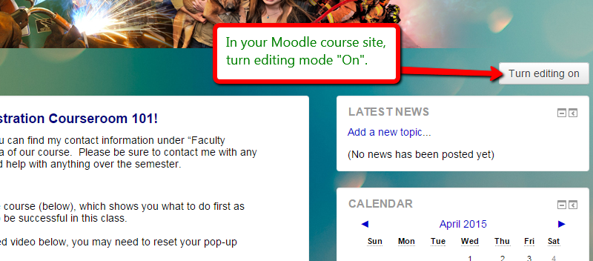

1. Using the unzipped files you downloaded onto your computer from Blackboard, you can simply [1]drag-and-drop those files one by one into the preferred content/module areas of your Moodle course site:

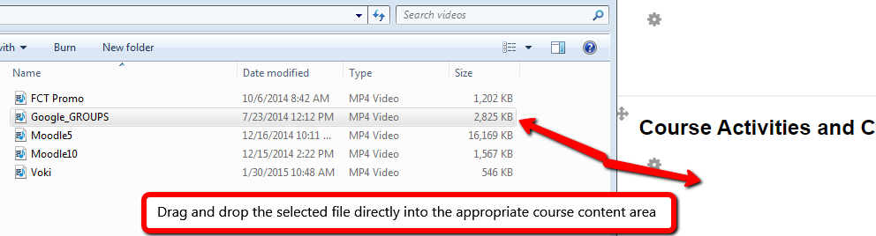

**Embedded web-videos (YouTube, etc.)**

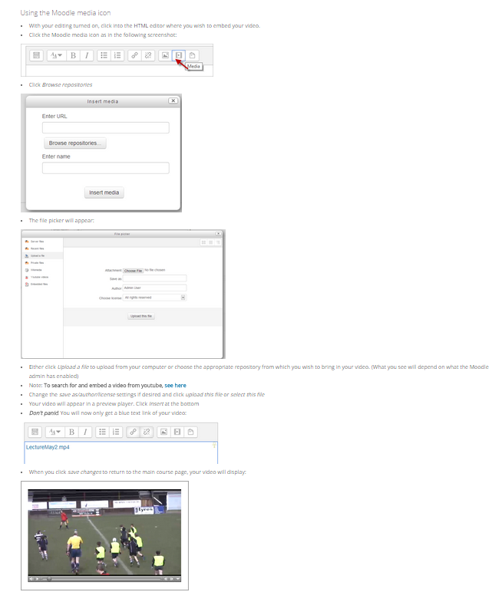

***OR* - Embed web-videos with a hyperlink:**

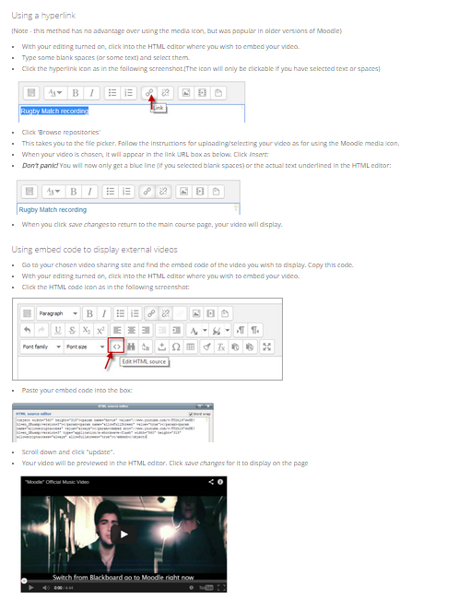

1. Right-click on the file, and while continuing to hold down the right mouse button, drag the file to the desired location in Moodle.