Blackboard: How to Export a Test, Survey, or Pool

1. On the **Control Panel**, expand the **Course Tools** section and click **Tests, Surveys, and Pools**.
2. On the **Tests, Surveys, and Pools** page, click **Pools**.
3. On the **Pools** page, access the contextual menu for a test, survey, or pool.
4. Select **Export**.
5. Click **OK** in the pop-up window to save the file.

* If your school licenses content management, two export options will appear in the contextual menu. To save the file to your computer, choose **Export to Local Computer**.

Moodle: How to Import a Test, Survey, or Pool

To import questions into Moodle's [Question bank](https://docs.moodle.org/22/en/Question_bank):

(1). Use the Question Bank link in course administration and select **import**. (2). Select the question type / file type to import

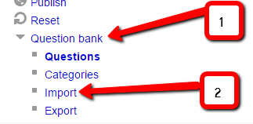 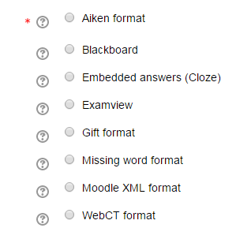

(3). Set options as preferred:

**General:** pick the category, determine if the context and category information that maybe contained in a GIFT or XML file should be used.

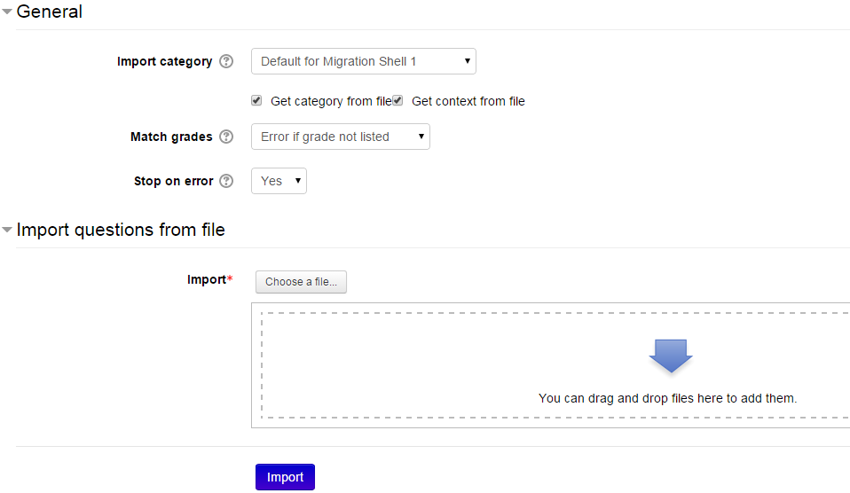

**Determine the file to import:**

* Import from file upload. Use the browse function to import a file from your computer. Use the "Upload this file" button to import the questions.

**OR**

* + Import from a file already in course files. A popup window will take you to the course files start page. Use the "Import from this file" button.

Select what should happen if there are no grades or an error is detected in the import process.