**Transferring Bb Discussion Forums to Moodle**

The most effective way to transfer Bb discussion forums to Moodle is to use copy / paste, as shown below:

1. Open your Bb and Moodle courses side by side, in different browsers and windows. This will save time.

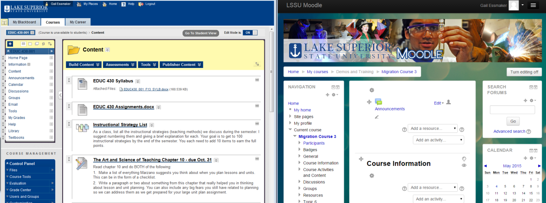

1. In your Bb course, open the discussion forum you want to transfer in "Edit" mode:

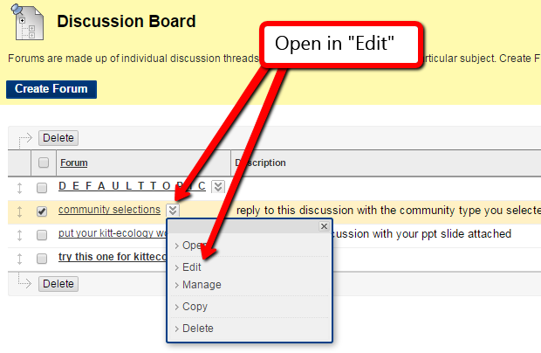

1. In your Moodle course, turn on "Edit" mode:

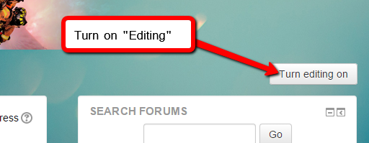

1. In Moodle, use the dropdown menu labeled "Add an Activity" in the content area into which you want to add the discussion. Select "Forum":

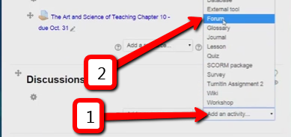

1. Highlight the forum name, and use the right-click functions **OR** Ctrl-C + Ctrl-V to copy and paste the name from Bb to Moodle. Do the same for the body of text in the forum topic and instruction areas. If your browser does not support the right-click copy/paste functions, use the keyboard shortcuts Ctrl-C + Ctrl-V.

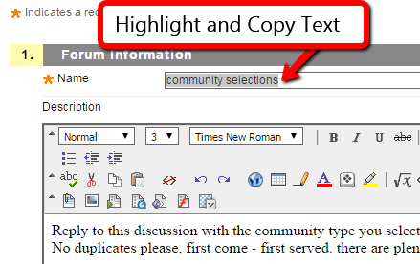 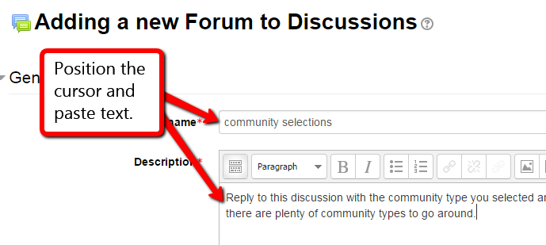

**Copy / Paste**

1. Once your content for the Discussion Forum is copied into Moodle, set the forum criteria as needed:

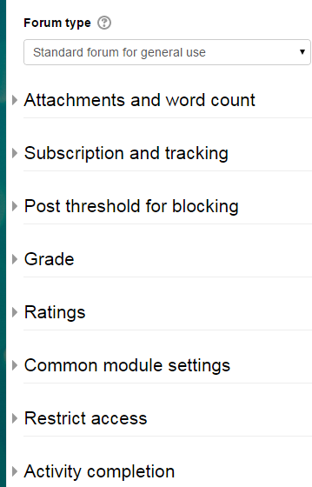

1. When the criteria for forum type, access, grading, etc. have been set, save and return to the course:

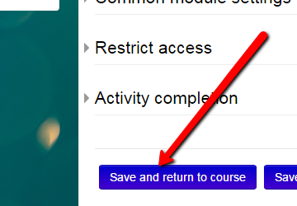

1. On your course home page, the new forum will display in the module content area:

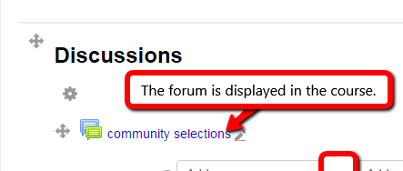

1. The "eye" icon can be used to hide the forum if you'd like, or you could use the "Restrict Access" to set the dates when the forum becomes available to students. The forum's criteria or restrictions can be edited at any time using the "Edit" dropdown.

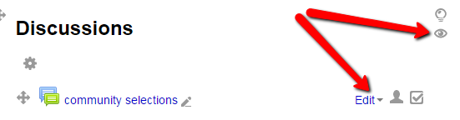

1. If you would like to view the forum as your students will see it, go to the Course Administration menu and select "Switch Role to Student". This enables you to see the course and all its content as it is seen by the students.

